1. Chain Stopper add certificate refresh Issue. After adding the chain Stopper when i select same to add more Old data added shows

2. Chefguard add form refresh issue in the date callender

3. Winch brake test kit add form refresh issue

4. Winch in assign winch form dropdown not showing the Order, I saved it in the Mooring Winch.

5. Add mooring operation Line name are Missing

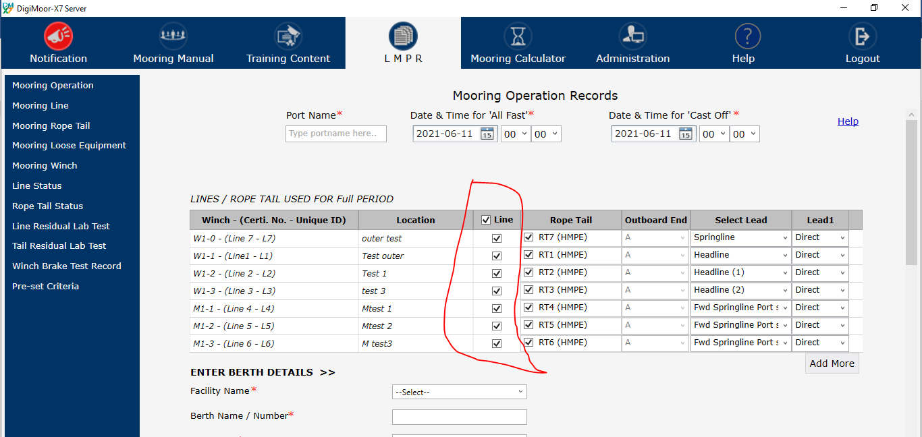

6. Inspection setting Chefguard Not applicable not visible

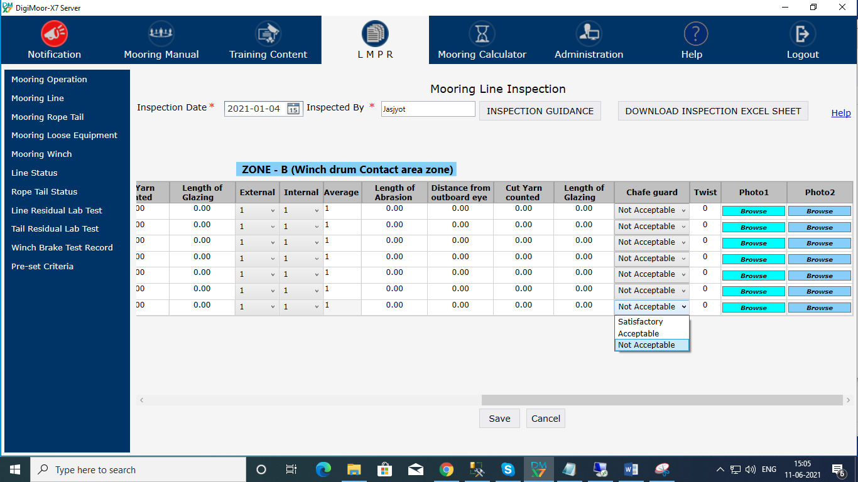

7. Rope tail Inspection date not updating as the latest Inspection was done on 10-06-2021.

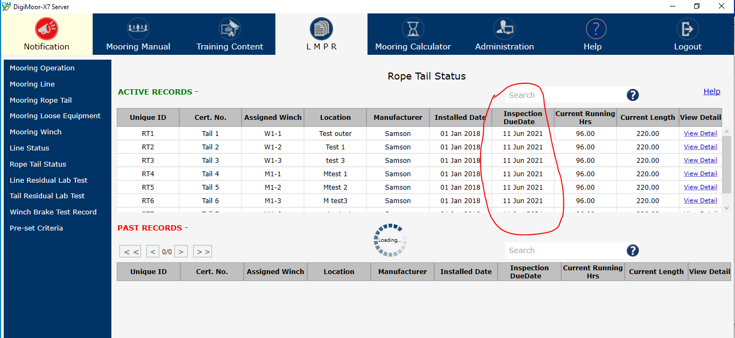

8. How to find the Serial number of the PC for key activation generation.

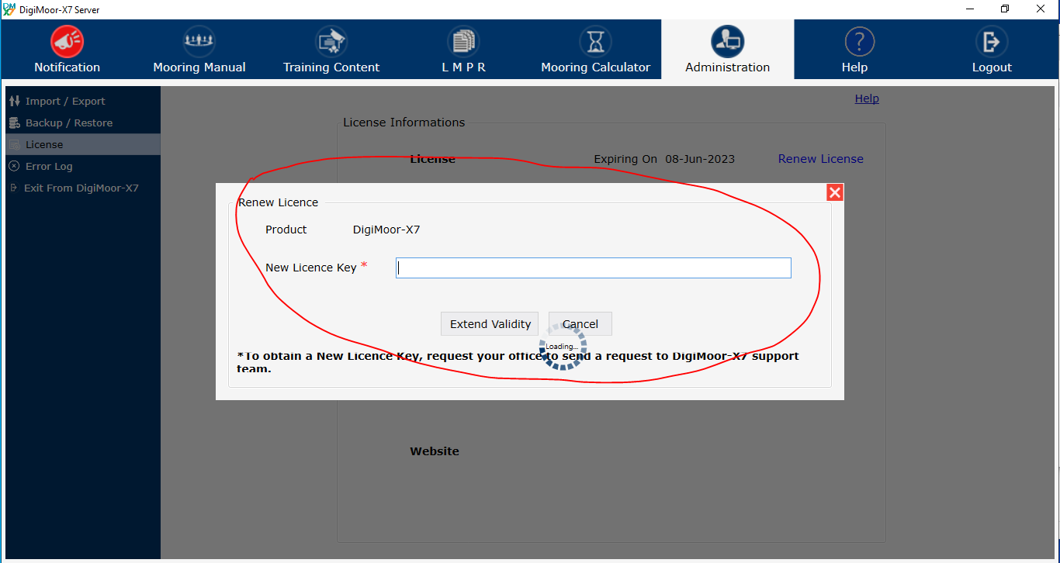

How you tested the Keys for next 1 year ?

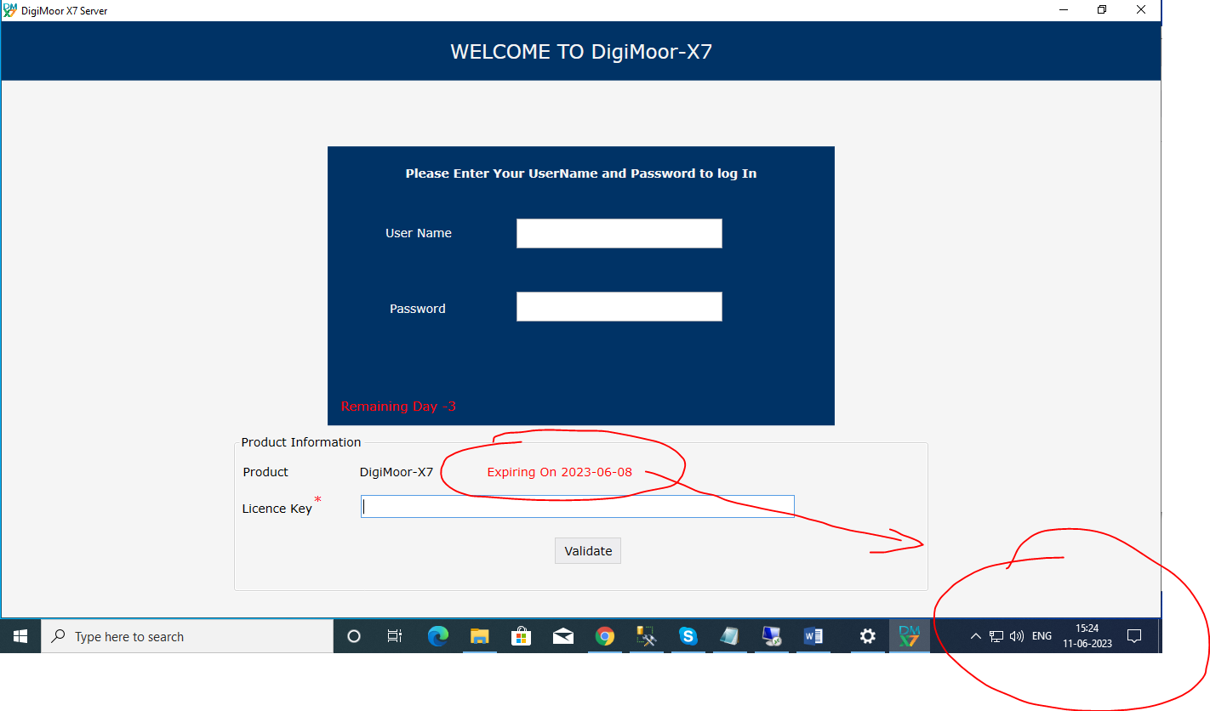

9. Where is the DigimoorX7 PC Serial Key for creation, could not find the serial keys to generate the Activation keys

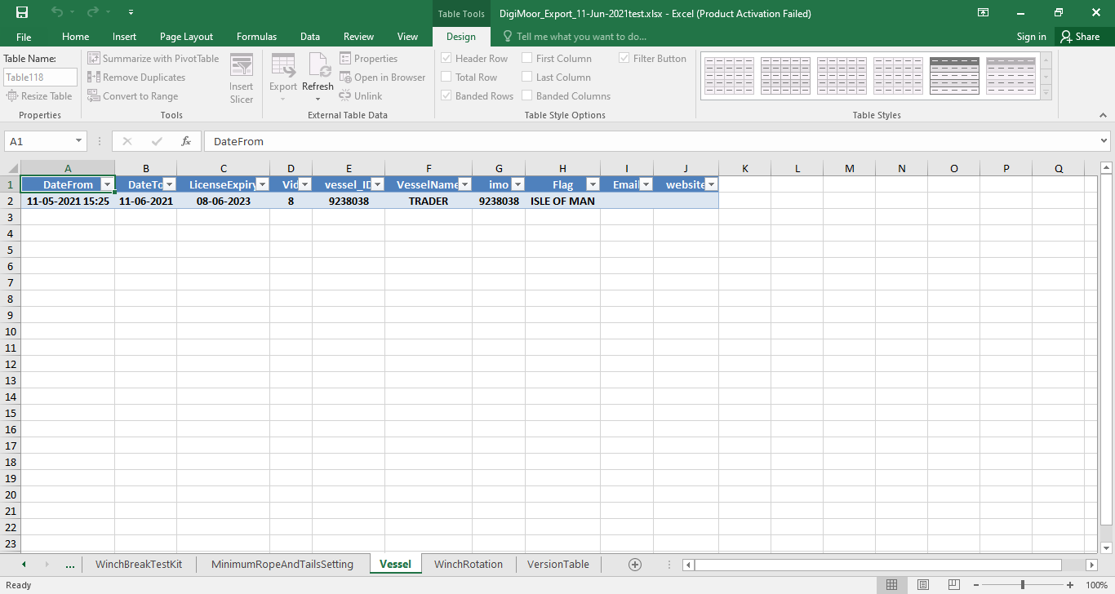

10 Rope tail inspection date is not updating, I added inspection day before the Inspection Due date, but date don’t changed

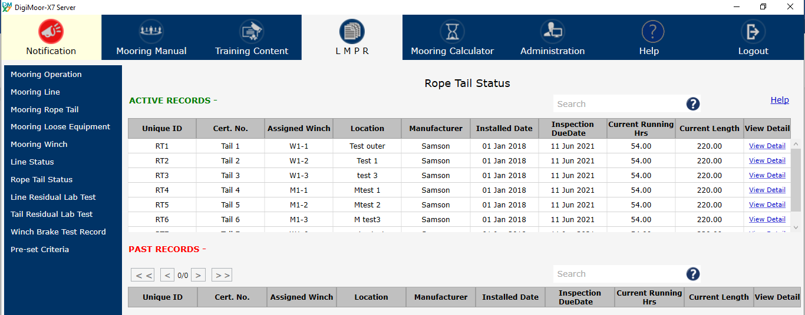

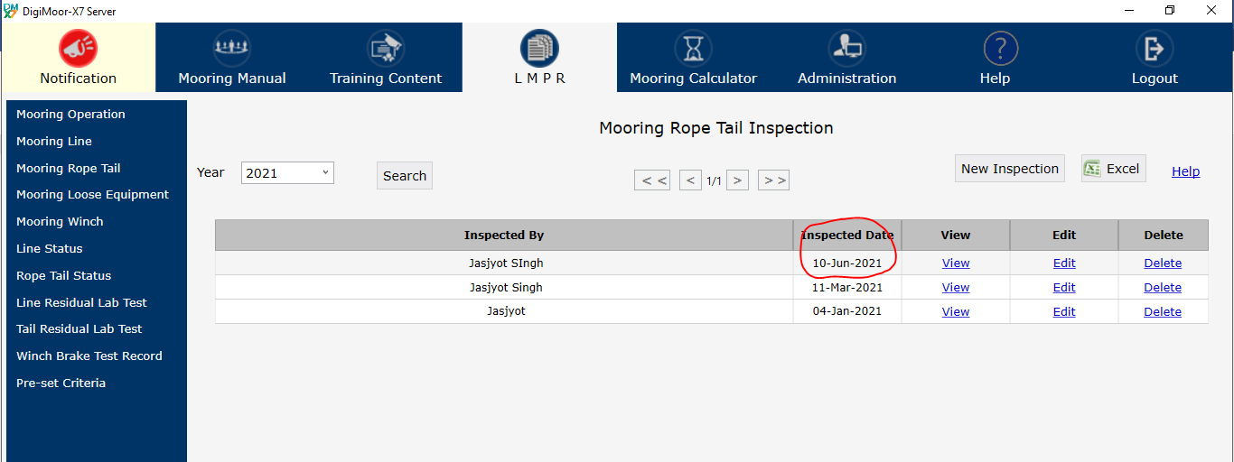

Rope tail setting available in the Software

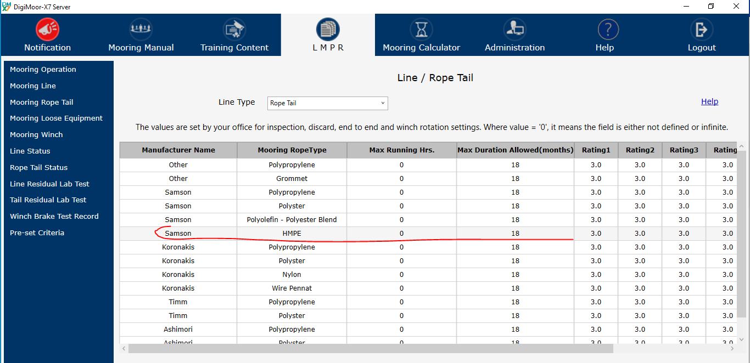

11. Installation procedure is pending as the Product installation and Activation is not completed. There is not process available for the same …..